Lesson 4 Demo 14: Configure a Configmap as a Variable in the Pod

This section will guide you to:

* Configure a Configmap as a Variable in the Pod

This lab has one sub-section, namely:

1. Configuring a configmap as a Variable in the Pod

**Note:** If you don’t have an existing Kubernetes cluster, refer to the Demo 1.1 of Lesson 1.

**Step 1:** Configuring a configmap as a Variable in the Pod

* Start the kubernetes cluster in the lab
* Run **kubectl delete configmap --all** to delete all existing configmaps from previous labs

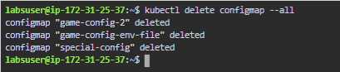

* To configure a configmap from values with variables, use kubectl create configmap with the --from-literal argument to define a literal value/constant value for variable as shown below:

*kubectl create configmap special-config --from-literal=special.how=very --from-literal=special.type=charm*



* You can pass in multiple key-value pairs. Each pair provided on the command line is represented as a separate entry in the data section of the configmap
* You can also show the configured configmap using yaml as output using kubectl command as shown below:

*kubectl get configmaps special-config -o yaml*

